UPDATED PAGES

**Course Page**



Add Assignment



View Assignment



Document Manager



Email Client Webmail

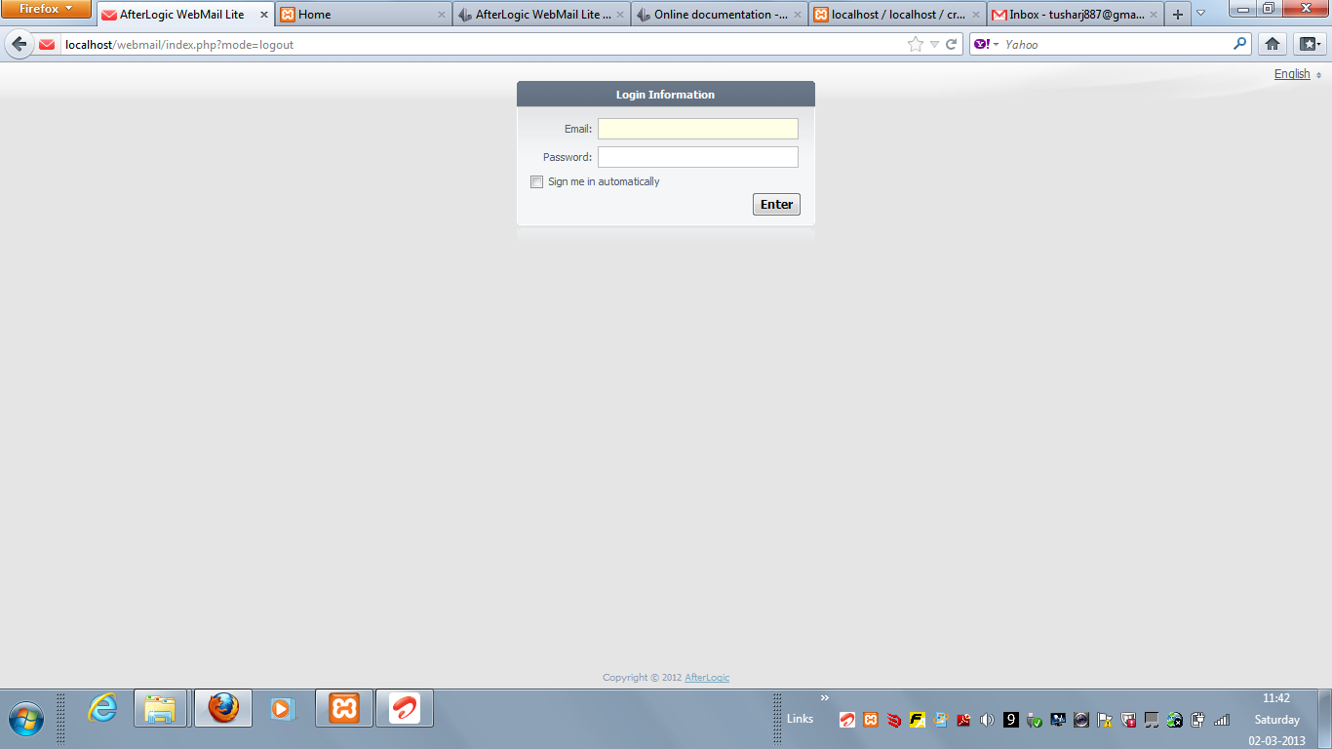

**ADMIN**

Admin Users Page



**2. RELATION BETWEEN WEB PAGES**

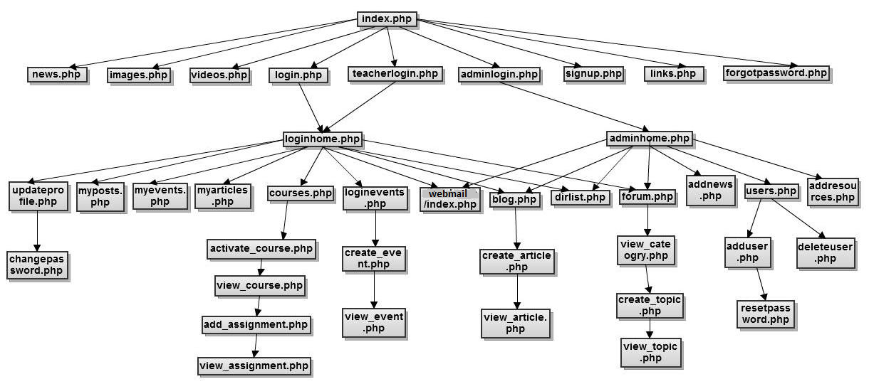

**3. DATABASE SCHEMA**



**4. FUNCTIONALITIES COVERED**

**Basic Features:**

➢ Signup facility for students where their account is activated on the dashboard. Teachers

are already provided with a unique id and password by the college so they can directly

access their account.

➢ User authentication has been performed at the time of signup and also at the time of

login. Student details are already stored in the database by the admin which could be used

to authenticate the student and prevent anybody else to access other’s accounts.

➢ Student Dashboard

This view will have details that students would use the most when they enter your

website. In the home page latest news and announcements of class events or college

events are shown.

➢ Add activities/events and comment on them. Each student has access to his classroom

events and can create and comment on them. Every teacher has access to his branch

events and can create and comment on them.

➢ Personal document Manager that allows user to add/delete document

➢ Email client : Php WebMail Service

➢ Blogging

➢ Discussion Forum

➢ Students can access their courses through their account. They can download the course

assignment and even submit completed assignment.They can receive their grades from

the teacher after the submission.

➢ Teachers have the facility to activate their course on the dashboard by which they can add

assignments to be submitted online or offline.They have the flexibility to provide their

own submission url.They can give grades on the dashboard itself by which it can reach to

the relevant student only.

➢ Teachers have the power of deleting the course that they had activated on the dashboard.

The class teacher has the power to delete any event belonging to his class.

➢ Admin can add/edit/remove any user on the website.He can edit contents on the blog and

forums.Also he can add the news and resources would be available at the home page. He

can view all the documents of the teachers and the students.

➢ Admin can change user’s password and provide a new one.

**Additional Features :**

➢ **Email support on events and assignments added for a particular class.Each class**

**student gets a notification whenever any new class event or course assignment is**

**created.He also has the option to unsubscribe to the emails.**

➢ **Forgot Password : Each student can retrieve his/her password by entering his id no**

**and email id. He will be sent password in the mail.**

➢ **In line editor facility for easy editing of contents posted by the author.**